MECH 888: Nonlinear Optimization
Professor: Dr. Florin Bobaru
Author: Ricardo Jacome

Road Curvature Model Optimization
Abstract
With the advancement of autonomous vehicle technology, the use of sensors has become the cornerstone of any autonomous navigation architecture. However, limitations such as weather disruptions, often make sensors to be unreliable and even have severe consequences on autonomous navigation. A new method is proposed in which a guidance data profile is generated independently of vehicle sensors to provide vehicles with enough information to traverse curves. This method relies on vehicle dynamics and street design standards coming from the American Association of State Highway and Transportation Officials. An optimization routine is implemented to obtain guidance parameters such as curvature, velocity, and wheel angle. This optimization routine is divided into two main sub-optimization problems. The results show that the guidance profiles generated can be optimized with reasonable values for providing a ride that can complement existing autonomous vehicle technology.
Introduction
Vehicle technology has evolved up to the point where now is desired that autonomy takes place over conventional drivers. This has been attained primarily with the use of sensors that perform object detection, lane identification, and other similar tasks. At the same time, infrastructure development has been evolving up to a point where wireless communication are being developed to aid vehicle navigation. This Vehicle to Infrastructure (V2I) communication scheme has improved some levels of vehicle autonomy by providing insights of traffic data to autonomous vehicles [1]. Such as informing traffic jams ahead of time or sending a vehicle when a traffic light is about to change. Improvements on roadside technology have opened the opportunity to implement V2I systems in roadside systems such as barriers or guardrails, which can be used to connect vehicles to their environment outside of urban areas. However, little to no improvement has been made on what to use to aid vehicles during navigation of highways [2]. This project focuses on creating a reference path for highways such that vehicles using V2I technology can navigate through them effectively. The main advantage would be the option to have a navigation reference that is independent of vehicle vision sensors. Similarly, options such as high accuracy GPS are too costly to implement in every vehicle such that this new option accommodates to already built-in communication models constructed in current vehicle technology [2]. With this guidance reference, vehicles can access the road profiles as they approach them and be able to navigate them in the case of adverse conditions such as weather instabilities.
Background
In the United States, the prevailing standards for road design come from The American Association of State Highway and Transportation Officials, referred as the Green Book. This book offers an extensive review of road design considerations that comply with vehicle dynamic behavior. Special consideration is given to curve maneuvering because there are centripetal forces that need to be balanced with a combination of road factors to maintain vehicle stability. The dynamics are formulated using Newton’s Second Law of motion, which takes into consideration both road and vehicle characteristics. Road design parameters include, road friction, superelevation, and maximum width, while the vehicle parameters considered are velocity, acceleration, trackwidth, and vehicle length. These are summarized with the following formula [3]:
$$\frac{v^{2}}{gρ}=\frac{μ+0.01e}{1-0.01μe} Eq.1$$
Where:
$v=$ Vehicle velocity (m/s)
$e=$Superelevation (as a percentage)
$g=$ Gravitational acceleration (9.81 m/s²)

$μ=$Coefficient of side road friction
$ρ=$ Radius of curvature (m)

Note: Mathematical derivations of Eq. 1 are not provided in this report.

This formula relates most of the parameters that can be involved from any general vehicle and general street. In the case of street design, road friction and superelevation are already implemented on most roads. Vehicles can vary their velocity and heading accordingly as they traverse any curve. However, the factor that unites both the road and the vehicle is the radius of curvature. From geometric considerations and Newton’s Second Law, it is possible to find another equation that relates more vehicle parameters to the radius of curvature as follows [4]:
$$δ= \left(57.3L+\overline{UG}v^{2}\right)ρ^{-1} Eq.2$$
Where:

$δ=$ Wheel directional angle (deg)
$ρ=$ Radius of curvature (m)
$v=$ Vehicle velocity (m/s)
L = Vehicle length (m)
$\overline{UG}=$ Understeer gradient (deg-s²/m)

Note: Mathematical derivations of Eq. 2 are not provided in this report.
Since the Radius of Curvature belongs to the set of all real numbers, to avoid division by zero, the inverse function is used. This is known as Curvature and is depicted as : $κ=ρ^{-1} (m^{-1})$. Curvature is unique for every vehicle type when traversing any arbitrary road. However, all roads have already a pre-determined standard curvatures that were designed for a distribution of vehicles as discussed before.
Furthermore, curvature can be directly related to a vehicle’s heading angle through an orthogonal shift for an instantaneous point in time [5]. Such that heading angle of vehicle can be easily obtained from a curvature profile. For this reason, being able to provide vehicles with this pre-determined curvature poses a new guiding factor that autonomous vehicle technology can implement into their decision algorithms for navigation. Such that vehicles will have a baseline road profile to navigate in the absence of reliable sensor information. Examples where it can improve their reliability are conditions of adverse weather effects or poor lane markings which can disable sensor information.
There exist multiple types of roads in which curvature changes as a function of segment length (i.e. $κ(s)$ ) to provide both stability and comfort to drivers. These are divided in two categories, horizontal and vertical curves. Horizontal curves focus on the direction of the centerline, while vertical curves focus on the slope of the centerline. Horizontal curves are divided into 4 main categories shown in Figure 1. For this project, only horizontal curves are considered because they constitute most of the implemented roads available.
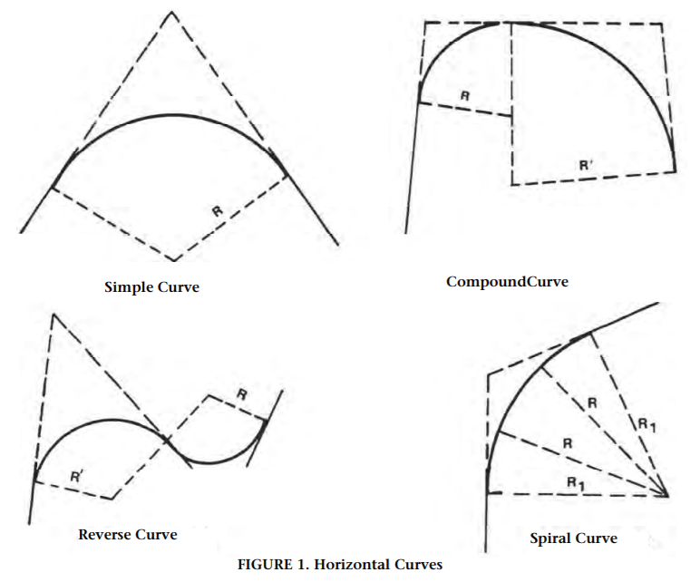
Figure 1. Horizontal Curves [3]
Thus, for this report, curvature models were developed that can represent these types of roads. However, to attain an optimized curvature model that can be applied to general vehicles. An optimization problem needs to be defined that utilizes both real road data and vehicle parameters.

Mathematical Road Curvature Models
All horizontal curves shown in Figure 1 are made of curvatures with constant, and/or linear slopes. To create a general model to be optimized, the following model is proposed:
Piece-wise linear model:
$κ_{1}=\left(\frac{x_{5}}{x_{2}-x_{1}}\right)\left(s-x_{1}\right)\left[φ\left(s-x_{1}\right)-φ\left(s-x_{2}\right)\right]+x_{5}\left[φ\left(s-x_{2}\right)-φ\left(s-x_{3}\right)\right]+\left(\left(\frac{x_{5}}{x_{4}-x_{3}}\right)\left(-s-x_{3}\right)+x_{5}\right)\left[φ\left(s-x_{3}\right)-φ\left(s-x_{4}\right)\right]$ M.1
Where:
$φ\left(x-a\right)=$ Unit Step Function with a-shift
$x_{i}=$ Variables that describe curvature function with $i∈[1,5]$
M.1 was mathematically designed to be continuous for all $s$ and offers the flexibility of having its $x_{i}$ parameters to be easily identified as basic geometric properties of a trapezoid. This is illustrated in Figure 2 for the general model $κ_{1}$ along $s$ with parameters $x_{i}$.
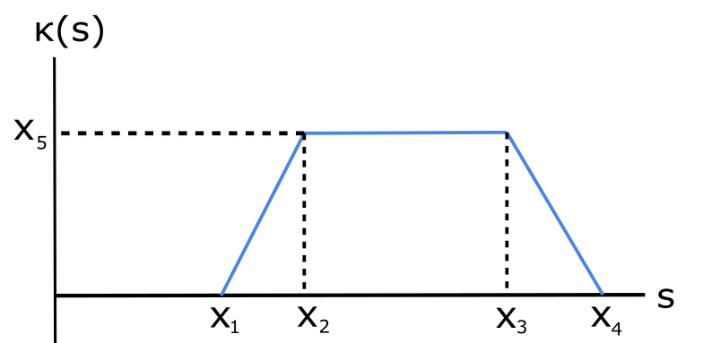
Figure 2. General curvature model 1 (M.1), with designated variables
Note: Mathematical derivations of M.1 are not provided in this report.
Optimization Problem Formulation
To obtain the curvature discrete data, a previous study has been performed which outputs the curvature values needed to be compared with the curvature models [5]. These models are subject to an unconstrained Least Squares Error - Minimization problem (denoted as Pr. 1) such that:
$$\min_{x}{{\left\|κ_{m}(s)-\hat{κ}[s]\right\|}^{2} Pr.1}$$

Where:

$κ_{m}(s)=$ Road curvature model $m$ in terms of segment $s$and constants $x_{1},…,x_{n}$
$\hat{κ}[s]=$ Discrete road sampled curvature data

This minimization problem (Pr.1) will test different analytical curvature models and obtain appropriate parameters for each of them accordingly. It is important to note that the models $κ_{m}$ can be either linear or non-linear.
Pr.1 will focus on representing models $κ_{m}(x_{1},…x_{n})$ as a representation of any generic road data input. However, to take into consideration the vehicle dynamic stability, Equation 1 and Equation 2 are used to generate a second minimization problem (Pr.2) that will minimize the steering wheel angle $δ (or y_{1})$ and vehicle velocity $v ({or y}_{2})$ for every segment on $κ_{m}\left(s\right)$ with the following objective function:
$$\min_{y} y_{1}- \left(57.3L+\overline{UG}y_{2}^{2}\right)κ_{m}(s) Pr.2$$
$$subject to:$$
$$\frac{y_{2}^{2}}{g}κ_{m}(s)-\frac{μ+0.01e}{1-0.01μe}=0$$
This will find the optimized combination for both traveling velocity and wheel angle that uses the model $κ_{m}(s)$ as part of their process. It is important to note that Pr. 2 must be solved iteratively as many values the vector $κ_{m}$ contains. Pr. 2 is a non-linear constrained optimization problem in which the vehicle parameters ($L,\overline{UG}$) and road parameters ($μ,e)$ are regarded as constants for any generic road/vehicle. In general, there exists design vehicle ranges, and steering wheel angles such that extra constraints could be added to Pr. 2 in the following manner:
$${v_{min}<x}_{2}<v_{max} \& δ_{min}<x_{1}<δ_{max} C.1$$
In practice, these constraints will be inactive for the most part. However, these can be defined by regulatory standards and are important to denote since dynamical formulas do not account for speed limit regulations. In other words, going at a slow speed such as 45-mph on a 75-mph road will not violate dynamic stability requirements but might pose a risk for upcoming traffic.
Note: The understeer gradient $\overline{UG}$ is a function of many tire dynamic parameters including velocity and wheel angle. Such that more complicated versions of Pr.2 can be created. However, for this project, it will be regarded as a constant that complies with C.1.
To combine both Pr.1 and Pr. 2 iteratively, the following pseudo-code was created to illustrate the whole optimization routine.
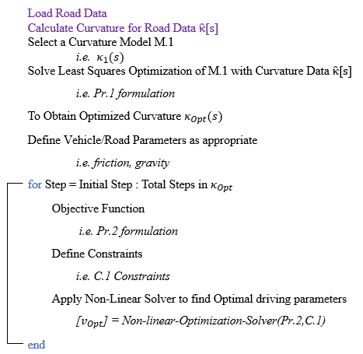
Figure 3. Pr.1 and Pr.2 Solved Iteratively Pseudo-Code
Implementation/Results
Least Squares Minimization Pr.1

To optimize Pr. 1, a sample curvature data was generated so that it resembles a compound curve (Figure 1) with Gaussian noise added. The optimization was performed with MATLAB’s lsqcurvefit optimization routine (see code in Appendix) [6]. It is crucial to note, that for convergence of Pr. 1 with M.1, starting points $x_{i}$ must be given, and they must not be repeated values so that $x_{i}≠x_{i-1}$. A sample optimized M.1 is shown in Figure 4 along with Table 1 with its corresponding coefficients. The behavior of M.1 under many datasets was tested, and it is noticeable how data curves that lack a “downward” slope at the end of the are still being able to be modeled by M.1. The model can do that by providing a combination of $x_{3}$ and $x_{4}$ so that the slope of that section is approximately constant.

Table 1. Variables obtained for M.1

Variable | Quantity
$$x_{1}$$ | 1.543
$$x_{2}$$ | 14.505
$$x_{3}$$ | 41.925
$$x_{4}$$ | 151.046
$$x_{5}$$ | 0.0261

Figure 4. Optimization of Curvature M.1 from Pr. 1

Visualization of Non-linear Constrained Optimization Pr.2
A sample for a single data point from $κ_{1}\left(s\right)$ is used to generate the contour plot in Figure 5, with ranges that are realistic for C.1. It is noted that the minimizer of Pr. 2 lies somewhere in the line generated from the intersection of Eq. 1 and Eq. 2. Also, Table 2 provides with the basic road and vehicle parameters that are used throughout Pr. 2. It is important to note that the model is unbounded without the aforementioned constraints [7].

Table 2. Input Parameters for M.1
Parameter | Quantity | Unit
$$κ$$ | 0.0167 | m⁻¹
$$\overline{UG}$$ | 1.95 | deg
$$L$$ | 2.5 | m
$$g$$ | 9.81 | m/s²
$$e$$ | 6 | %
$$μ$$ | 0.4 | ----
Figure 5. Contour Plots for M.
AMPL for Optimization of Pr. 2
To minimize Pr. 2, the AMPL modeling language was used, so that complexity of selection for appropriate optimization solvers is reduced [8]. The basic idea of AMPL is to provide 3 files, of the type .mod, .dat, and .run. These are used along with a server that is able to compile all files and provide an optimized solution. The highest versatility of this modeling language is that resembles closely mathematical formulations, such that the transition from math writing to computer input is greatly reduced. Summarizing: .mod files contain 4 main components:
param: Parameters, which are values can be arbitrarily changed, and are obtained from .dat files.
var: Variables, which are the optimized variables that need to be found.
minimize: The objective equation to be minimized, which should contain all variables, and some (not all) parameters defined before.
subject to (or alternatively, s.t.): Constraints that are applied to the objective function, that can contain some or all variables and parameters previously defined.
In general, all parameters are defined in the .dat file, and variables need to be given an initial guess, which is also done in the .dat file (see code in Appendix for example). Then, the .mod file takes all the data to optimize the model (equations and constraints). Finally, the .run file is utilized to simply compile the other 2 files together. It is also used to display specific values or results as deemed appropriate by the user.
Below, Figure 6 is the output obtained from running the files on the Appendix. As it is noticed, this shows the optimized wheel angle and velocity from Pr. 2 subject to C.1 as well. Also, the solver used was MINOS 5.51.
ampl: include Problem2.run
minimize Z:
-0.00331957*y[2]^2 + y[1] - 2.24198;

subject to C1:
0.00170234*y[2]^2 = 0.471311;

MINOS 5.51: optimal solution found.
6 iterations, objective -6.161032377
Nonlin evals: obj = 21, grad = 20, constrs = 21, Jac = 20.
Z = -6.16103
y[1] = -3
y[2] = 16.6391
Figure 6 AMPL Console Results for Pr. 2
For Pr. 2, the obtained angle is 3 deg, and velocity is 16.63 m/s or about 36 mph, which is a reasonable velocity for the input curvature 0.0167 m⁻¹. Thus, at this curvature segment, the velocity and angle have been optimized. However, this is for a singular curvature data point. Thus, to obtain the ideal velocity and angle profiles, the routine in Pr. 2 needs to be implemented in every segment length and curvature from Pr. 1.
The results from the Pseudo-Code in Figure 3 were implemented in a single MATLAB routine and its results are shown below in Figure 8. The road data comes from a previous study where a mathematically ideal spiral curve was created (Figure 8 left). The solution to Pr.1 was obtained (Figure 8 center) and was utilized to obtain an optimized velocity profile (Figure 8 right). It is important to remark that the road data was created mathematically to be exact with road design standards, thus no noise is present during this implementation. However, it is appreciated how during a spiral curve, the velocity to provide an optimal ride changes during the transitions of constant and linear curvatures.
Figure 8. Road Data (left), Curvature Profile (center), and Velocity Profile (right).
Conclusions
In this report, a method to obtain optimized guidance profiles based on curvature was presented and analyzed. The method was constructed based from vehicle dynamics, and road design standards. The optimization tools were MATLAB and AMPL. The method was subdivided in a Least Squares Optimization part (called Pr.1), and an Iterative Nonlinear-Optimization part (called Pr.2). The results for this method show appropriate results for optimal velocity with a spiral curvature road data. In conclusion, the road curvature optimization method shows promising results for optimizing vehicle guidance parameters subject to road/dynamic constraints with general road data input given. Further implementation of this method could result in an upgrade for autonomous vehicle technology in which weather disruptions and poor road markings could stop being a problem for future vehicle generations.

References

- F. Arena, G. Pau, An Overview of Vehicular Communications, January 2019
- Stolle, C. Jacome R., and Sweigard, M. Virtual Barriers for Mitigating and Preventing Run-off Road Crashes, Phase I. DOI: 10.13014/K2TM78B5, October 2018
- A Policy on Geometric Design of Highways and Streets (The Green Book) Sixth Edition (American Association of State Highway and Transportation Officials, 2011).
- Gillespie, T.D., Fundamentals of Vehicle Dynamics (SAE International, 1992). ISBN:1-56091-199-9.
- Jacome, R., Stolle, C. and Sweigard, M., “Road Curvature Decomposition for Autonomous Guidance,” SAE Technical Paper 2020-01-1024, 2020, doi:10.4271/2020-01-1024.
- MATLAB reference Least Squares Optimization: https://www.mathworks.com/help/optim/ug/lsqcurvefit.html Date of Access: 4-10-20
- Dixit, N.R., “Evaluation of Vehicle Understeer Gradient Definitions”. Master’s Thesis, 2009. (used to obtain parameters)
- Robert Fourer, David M. Gay, and Brian W. Kernighan “AMPL: A Modeling Language
for Mathematical Programming” Second edition, ISBN 0-534-38809-4
- MATLAB reference Non-Linear Constrained Optimization: https://www.mathworks.com/help/optim/ug/fmincon.html Date of Access: 4-10-20

- Appendix
Codes
MATLAB Contours

clear all; clc; close all
% From Carsim [9] paper
% At Rho = 30 m -> U = 1.91
% At Rho = 60 m -> U = 1.95
y1 = linspace(-10,10); %Resonable Angles
y2 = linspace(0,40); % Reasonable Speed Ranges (m/s)
% 40 m/s ~ 90 mph ~ 144 km/hr
L = 2.5; % m
g = 9.81; % m/s^2
%AASHTO values
e = 6; mu = .4;
U = 1.95; K = 1/60;
[X1,X2] = meshgrid(y1,y2);
Z = X1 - (53.7*L+U*X2.^2)*K;
figure; meshc(X1,X2,Z); hold on
Z2 = - X2.^2*K/g + (mu + 0.01*e)/(1-0.01*mu*e);
meshc(X1,X2,Z2); colorbar;
xlabel('y1'); ylabel('y2')

MATLAB M.1 Pr.1 Minimization
s = 1:.01:30; n = numel(s)-1;
y1 = (2.*s(1:n/2) - 3)*1e-3;
y2 = 26*ones(1,n/2)*1e-3;
y1o = awgn(y1,25,'measured');
y2o = awgn(y2,25,'measured');
y = [y1o y2o];
x0 = [1 2 3 4 5];

fun2 = @(x,s) ((x(5)./(x(2)-x(1))).*(s - x(1))).*(heaviside(s-x(1)) - heaviside(s-x(2))) +...
x(5).*(heaviside(s-x(2))-heaviside(s-x(3))) + ...
( ( x(5)./(x(4)-x(3))).*(-s+x(3))+ x(5) ).*(heaviside(s-x(3)) - heaviside(s-x(4)));

x = lsqcurvefit(fun1,x0,s(1:end-1),y)
times = linspace(s(1),s(end-1));
figure
hold on; plot(s(1:end-1),y,'bo')
plot(times,fun2(x,times),'k-','linewidth',2)
legend('Data','Fitted Response','location','best');
title('Optimization of Curvature Model \kappa_1'); grid on
xlabel('Segment of Length s'); ylabel('Curvature \kappa');
xlim([times(1), times(end)+5])

AMPL Model File: Problem2.mod
param L > 0; # m
param K > 0; # m^-1
param U > 0; # deg
param g > 0; # m/s^2
param e > 0; # (Percentage 0-100)
param mu > 0; # unitless

var y{1..2};
minimize Z: y[1] - (53.7*L + U*y[2]^2/g )*K;

subject to C1: y[2]^2*K/g - (mu + 0.01*e)/(1-0.01*mu*e) = 0;
subject to C2: y[1] <= 3;
subject to C3: y[1] >= -3;
subject to C4: y[2] >= 0;
subject to C5: y[2] <= 60;
AMPL Data File: Problem2.dat
data;
param L := 2.5;
param K := 0.0167;
param U := 1.95;
param g := 9.81;
param e := 6;
param mu := 0.4;

var y:=
1 1
2 1;

AMPL Data File: Problem2.run
#RESET THE AMPL ENVIROMENT
reset;

#LOAD THE MODEL
#model example3.mod;
model Problem2.mod;

#LOAD THE DATA
data Problem2.dat;

#expand Z,C1,C2,C3,C4,C5;
expand Z,C1;

solve;

display Z, y[1], y[2]

MATLAB M.1 Pr.1 Minimization with Pr. 2 Optimization Iteratively
clear; close all; clc
%Debugging, needs to find correct numbers.
%GPS DATA
%load('CVF9LatX.mat'); load('CVF9LongY.mat');
%Ideal AASHTO
load('MichXm.mat'); load('MichYm.mat');
%x2 = LatX'; y2 = LongY';
x2 = xm'; y2 = ym';
x2 = unique(x2); y2 = unique(y2);
x2 = x2(1:numel(y2));
X = [x2',y2'];
[L,R,K] = curvature(X);
K(1,:) = []; K(end,:) = []; L(1,:) = []; L(end,:) = [];
x2(1) = []; x2(end) = []; y2(1) = []; y2(end) = [];
figure; plot(x2,y2);
xlabel('X Coordinate (m)'); ylabel('Y Coordinate (m)')
title('Raw Road Data')
figure;
h = plot(x2,y2); grid on; axis equal; set(h,'marker','.');
xlabel('X Coordinate (m)'); ylabel('Y Coordinate (m)')
title('Road with Curvature Vectors')
hold on
quiver(x2',y2',K(:,1),K(:,2)); hold off
y = sqrt(K(:,1).^2 + K(:,2).^2);
s = L;
% Initial Conditions, NEVER repeat them.
x0 = [100 200 300 400 500];
% Curvature Model M.1
M1 = @(x,s) ((x(5)./(x(2)-x(1))).*(s - x(1))).*(heaviside(s-x(1)) - heaviside(s-x(2))) +...
x(5).*(heaviside(s-x(2))-heaviside(s-x(3))) + ...
( ( x(5)./(x(4)-x(3))).*(-s+x(3))+ x(5) ).*(heaviside(s-x(3)) - heaviside(s-x(4)));
% Pr.1
fprintf('Pr. 1, Least Squares Min. Has finalized');
options = optimset('Display','off');
x = lsqcurvefit(M1,x0,s(1:end),y,[],[],options)
snew = linspace(s(1),s(end),100); % <--- This defines the
% size of the "K_vector".
figure; hold on;
plot(s,y,'bo');
xlabel('S-Segment (m)'); ylabel ('Curvature(m^{-1})');
plot(snew,M1(x,snew),'k-','linewidth',2);
xlim([snew(1), snew(end)+5]);
legend('Data','Fitted Response','location','best');
title('Data and Fitted Curve'); grid on

% -------------------------
%Parameters
global K_temp e g mu U
% Vehicle Only
L = 2.5; %U = 1.95;
U = 3;
% Road Only
e = 6; mu = 0.3;
% Both
g = 9.81; K_vector = M1(x,snew);
% -------------------------
%Iterative Optimization Routine for Pr.2 given Optimized M.1
for i = 1:length(K_vector)
K_temp = K_vector(i);
% Objective Function Pr.2
fun = @(x) x(1) - (53.7*L + U*x(2)^2/g)*K_temp;
%C.1 (Bounds)
% lb = [-3,25];
% ub = [3,60];
lb = [-3,25]; % -3 < x1 < 3;
ub = [3,35]; % 55 < x2 < 80; mph
% There are no linear constraints, so set those arguments to |[]|.
A = []; b = []; % Linear In-equality Constraints
Aeq = []; beq = []; % Linear Equality Constraints
%Initial Conditions
x0 = [1/4,1/4];
%Constraints as an annoynomous function
nonlcon = @EqConstraint;
options = optimoptions('fmincon','Display','off');
Op(i,:) = fmincon(fun,x0,A,b,Aeq,beq,lb,ub,nonlcon,options);
end
fprintf('Pr. 2 Has finalized \n');
vOpt = Op(:,2);
figure; plot(snew,vOpt,'linewidth',3)
ylim([max(vOpt)-10 max(vOpt)+10])
title('Segment Length vs Velocity Optimized'); grid on
xlabel('S-Segment (m)'); ylabel ('Velocity (m/s)');
figure; plot(M1(x,snew),vOpt)
ylim([max(vOpt)-10 max(vOpt)+10])
title('Curvature vs Velocity Optimized'); grid on;
xlabel('S-Segment (m)'); ylabel ('Curvature(m^{-1})');

% Nonlinear Constaints (Not bounds)
function [c,ceq] = EqConstraint(x)
global K_temp e g mu
%Pr.2
% Nonlinear Inequality Constraints
c = x(2)^2*K_temp/g - (mu + 0.01*e)/(1-0.01*mu*e);
% Nonlinear Equality Constraints
ceq = [];
end

